Project Development Phase
Model Performance Test – Machine Learning-Style Template
Implement Client Script & UI Policy (Incident)
Date | 1 October 2026
Team ID | SWTID-2026-4755
Project Name | Implement Client Script & UI Policy (Incident)
Maximum Marks | 10 Marks
1. Project-specific test context
This is not a machine-learning model. The equivalent quality problem is deterministic authorization and validation logic: the same Incident state should produce the same control decision every time.
The project uses a ServiceNow Incident form and list with one High Impact Control UI Policy and three Client Scripts. The test focus below adapts the ZIP reference report type to the Incident project; it does not claim that a live execution was completed during report preparation.
2. Project metrics / equivalent parameters
S.No. | Parameter | Project-specific values / evidence
1 | Metrics | Control accuracy = expected decisions matching observed decisions ÷ total decisions; false allow target = 0.
2 | Tune the model | Not applicable. Tune UI Policy conditions, Client Script logic, role scope, and test fixtures instead.
3 | Validation method | Exhaustive Impact × Assigned To × edit path matrix plus repeatability and response-time checks.
3. Test scenarios and results
Test Case ID | Scenario | Test Steps | Expected Result | Actual Result | Status
ML-PT01 | True allow: valid high-impact save | Impact = High and Assigned To populated; submit. | Save is allowed and urgency/policy behavior is correct. | Pending execution | Pending
ML-PT02 | True deny: missing ownership | Impact = High and Assigned To empty; submit. | Save is blocked and field error appears. | Pending execution | Pending
ML-PT03 | False allow detection | Attempt State list edit or incomplete save. | No unauthorized State edit or incomplete high-impact save succeeds. | Pending execution | Pending
ML-PT04 | Reverse-condition consistency | Repeat High → Medium transition across records. | Policy reversal is consistent and Urgency becomes editable. | Pending execution | Pending
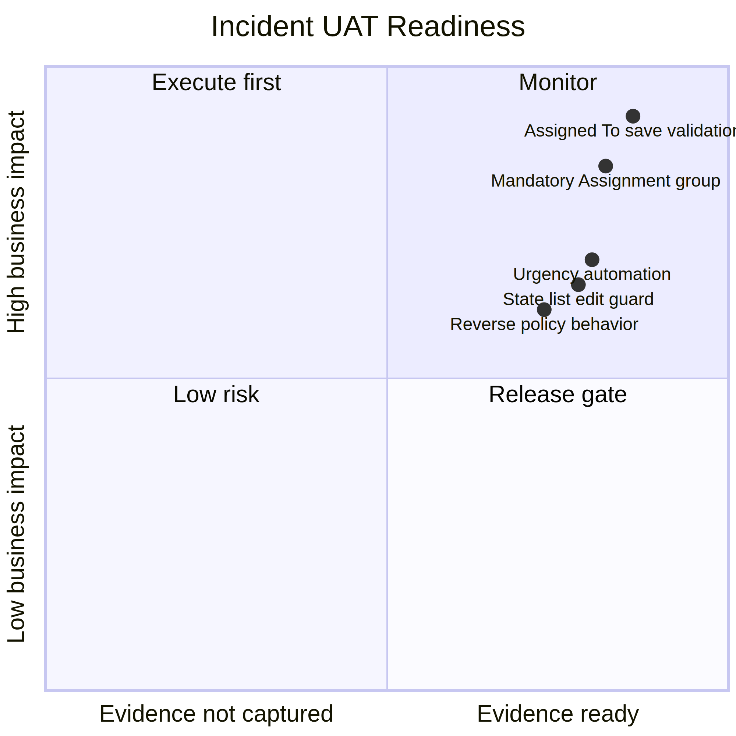
Original project-specific visual created for this Incident report.
4. Interpretation and evidence note
The principal quality target is zero false allows: no incomplete high-impact save and no direct State list change should succeed.
5. Execution status
Status at report preparation: Pending execution in the target ServiceNow instance. The source project PDF defines the configuration and expected behavior, but does not include live screenshots, response-time logs, or execution timestamps. Record those artifacts against each test case before final sign-off.
6. Conclusion
This report provides a project-specific Phase 5 testing baseline for Implement Client Script & UI Policy (Incident). The selected scenarios verify conditional field behavior, urgency automation, save-time validation, list-edit protection, and form-based updates while preserving the traceability expected in the supplied reference reports.

